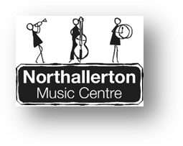

NORTHALLERTON MUSIC CENTRE

PRESENT

SPRING CONCERTS

AT

ALL SAINTS PARISH CHURCH,

NORTHALLERTON

ON

SATURDAY 1st April 2017

1.30pm
Senior Wind Band,
Junior Wind Band,
Jazz Ensemble

Including music from
West Side Story,
The Monkeys Medley,
Hairspray

11 am
Symphony Orchestra,
Choir, Guitar,
Senior Strings

Including music from
Saint-Sean Organ Symphony,
Albinoni Adagio,
Mozart Ave Verum

ADMISSION FREE

RETIRING COLLECTION TO COVER MUSIC CENTRE COSTS

For further information contact Su Evans on 01609 536715



