 | Individual visit consent and medical information | 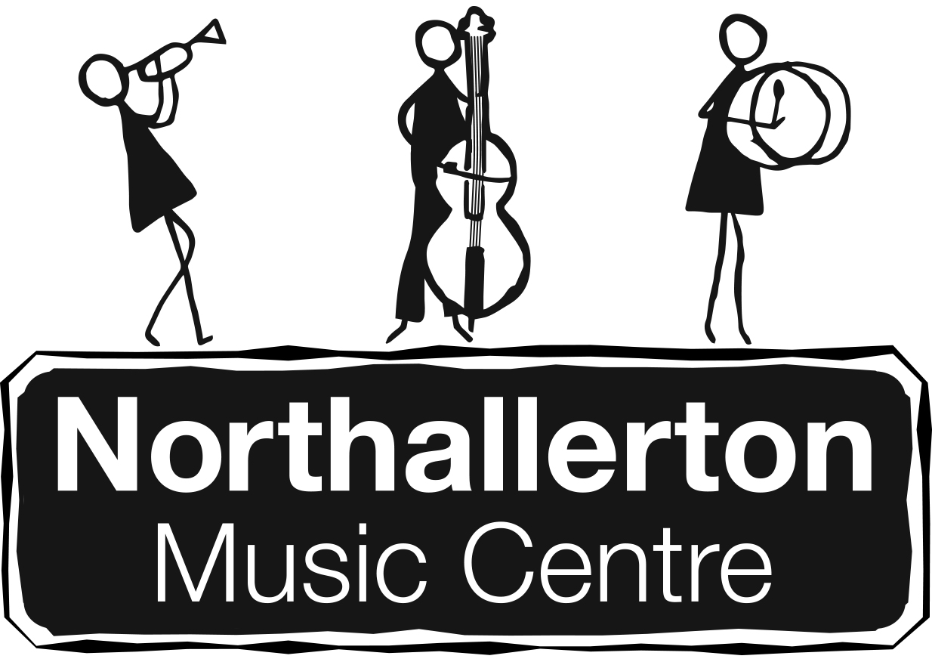

Offsite educational visit or adventurous activity
Visit/activity title | County Show, South Otterington
Group | Northallerton Music Centre Jazz Band | Date(s) | Sun 19th June 2016

Personal details
Full name of participant |  | Gender | Age | Date of birth
Home address

Emergency contacts (Please provide at least 2 contacts)
Name | Relationship | Telephone numbers

Doctor’s details
Name (if known) | Practice and village/town | Telephone number

Medical and welfare information
Please let us know if any of the following are relevant for the participant – please provide full details below
Relationship
Contact numbers
Recent serious illness | Yes/No | Asthma | Yes/No
Recent serious injury or broken limb | Yes/No | Allergies or historical reaction to medication | Yes/No
Epilepsy, seizures, convulsions or absenting | Yes/No | Taking any medication | Yes/No
Heart condition | Yes/No | Full tetanus vaccination | Yes/No
Diabetes | Yes/No | Any other medical, behavioural or diet issues | Yes/No
Swimmer | Yes/No | Water confident? | Yes/No

Please provide any medical, behavioural, dietary or other relevant information which will enable us to support and care for the participant during this visit or activity, or attach further documentation.
Please ensure that the participant has sufficient prescribed medication for the duration of the visit
Itinerary/programme
- I consent to the participant taking part in this offsite, educational visit or adventurous activity.  - I have received full information about the itinerary and programme; I understand its nature and agree to the participant engaging in all the activities described which may include activities in or near water.  - I understand that the programme may be changed by the Visit/Activity Leader in conjunction with any external provider due to weather or for other reasons.  - The information I have provided on this form is accurate at the time of signing. I agree that this information can be added to electronic management systems where required and I agree to inform the Visit/Activity Leader as soon as possible of any changes before the start of the visit. | Yes/No

Behaviour and conduct
- I understand that the participant must adhere to any code of conduct and behaviour set out by the Visit/Activity Leader, school, service or external provider. | Yes/No

Medical information
- I understand that if the participant has an existing medical condition then their doctor should be fully informed of the nature of the visit or activity in order to give medical advice on participation. | Yes/No

Medication
- I understand that the Visit Leader may give the participant prescribed or non-prescribed medication for which I have already given written consent and that I will be informed. | Yes/No

Medical treatment (delete those you do not consent to)
- I consent to the participant receiving any dental, medical or surgical treatment including anaesthetic or blood transfusion as considered necessary by medical authorities. | Yes/No

Please list any treatment you do not consent to so that medical authorities can be informed

Photographs and video recordings
- I consent to photographs and video recordings of the participant to be used by schools and services for teaching and coaching purposes and for use in marketing and publicity in line with relevant policies. | Yes/No

Further information
- I understand that I can request further information about administering medication, behaviour, charging and remissions, safeguarding and other relevant policies from the school or service. | Yes/No

Consent
Name of person giving consent |  | Relationship to participant (or state ‘self’)  Age  Date of birth
Signature |  | Date
To be signed by a parent/guardian/carer unless the participant is aged 16 years or older and is living independently, in which case they should sign it.
Please return this form to the person in the school or service who is organising this visit or activity.

For further information go to email su.evans@northyorks.gov.uk

